Limited English Proficiency (LEP) Training
by Melissa Taylor
2025

LEP Definition
- The inabilities to speak, read, write, or understand English at a level that permits effective interaction with health care providers.
- This definition includes person served who need speech or hearing assistance, blind, cannot read, or cannot write.

Official Language of the U.S.
What is the official language of the U.S.?
- English?
- Spanish?
- French?
There is no Official Language of the United States!

Regulations for LEP
- LEP regulations come from several different areas; there is no specific LEP law.
- The main regulation we look at is Title VI of the Civil Rights Act of 1964:
  - “…no person shall be subjected to discrimination on the basis of race, color, or national origin under any program that receives federal financial assistance.” SCCMHA and their Provider Network receive federal financial assistance; therefore, are bound by the LEP standards.
- National Origin is bolded in the previous paragraph because that is the part of the Civil Rights Act of 1964 the courts have determined deal with communication.
- Other Regulations:
  - Rehabilitation Act of 1973
  - American Disability Act of 1990
There are many other regulations that could be referenced, but you don’t have to know all the details.

Translation vs. Interpretation
Translation is translating the written word from one language to another

Interpretation is interpreting the spoken word from one language to another

Some examples below show the reason why we need to make sure we use a valid/approved translator when translating from one language to another. These statements help us understand we all look at things differently. The way you interpret this information is most likely not how it was intended.

- ‘Drop your trousers here for best results’ was one sign in a cleaners in Bangkok.
- German Coast Guard received multiple May Day calls from a ship that said they are sinking. The person manning the German Coast Guard said, “that is great, what are you sinking about?”.
- Tokyo hotel’s rules and regulations: “Guests are requested NOT to smoke or do other disgusting behaviors in bed.”
- Hotel elevator, Paris: “Please leave your values at the front desk.”
Q & A – Using Staff, Minors, and Family Members as Interpreters
Question: You know a staff person who speaks the same language as the person served that you are working with. Can you use staff for interpretation?
Answer: A staff person can be used to interpret if they have been proven to be competent in the language they wish to interpret. Each agency is responsible for deciding how to prove staff are competent interpreters.

Question: A person served you are working with speaks a language other than English. They are accompanied by a family member or a minor that speaks the same language. Can you use the minor or family member as an interpreter?
Answer: The only reason you can use a minor as an interpreter is in an emergency. If a minor is used as interpreter, there must be thorough documentation as to the nature of the emergency, the reason another interpreter was not used, and the outcome of using the minor as an interpreter.

Question: Can a family member be used as an interpreter?
Answer: A family member can be used as an interpreter if the option of FREE interpretive services were offered to the person served through an interpreter and the person served chose not to use the FREE interpreter. The person served must also ask for the family member to interpret through the FREE interpreter.

What is the Purpose of LEP?
- If you were banned from the U.S. and told you had to go to a training and pass a test before being allowed back into the country. As an English-speaking person, you were sent to a seminar or training that was presented in Vietnamese, how much would you get out of the presentation?
- You are presenting information to six people and the presentation is in English. Only three of the people you are presenting to speak English. You have treated everyone equally but have not gained “equal results”.
- The true purpose of LEP is to present information in a manner that every person served has the opportunity to understand the services they are receiving.

Dos and Don’ts of LEP
- DO treat every person served as a person served, regardless of their ability to speak English. Treat them with dignity and respect regardless of their ability to communicate.
- DON’T get caught up in trying to assess whether they could speak English if they wanted to – if someone requests an interpreter we are required to offer this service at no charge to them.
- DON’T suggest, expect, or even allow other person served to act as interpreters, even for scheduling appointments.
- DO clearly document any time you use an interpreter whose qualifications you are not familiar with.
- DO clearly document every time a friend or family member is used as an interpreter. Did the person served make the decision, after being clearly informed that they have a right to FREE interpretive assistance in their own language?

Postings
- Posters explaining the rights of person served to receive FREE interpretive services and Language Identification postings in several different languages are currently posted in all of the waiting rooms at every service site directly run by SCCMHA.
- It is a requirement to post the offer of FREE interpretive services in waiting rooms or other locations where person served regularly visit.

Language Assistance

- I Speak Cards are available at each SCCMHA service site. These cards are used to assist the person served in identifying the language they speak to staff.
- Communication Books are available at each SCCMHA service site to assist person served identified as having LEP. The Communication Books contain hundreds of pictures similar to the ones shown above.
- Major publications are available in English, English audio tape, Spanish, and Spanish audio.
- All requests for information in alternative formats should begin with a request to Customer Services.

Interpretive Services
- SCCMHA is required to provide interpretive services twenty-four hours a day, seven days a week.
- We have a contract in place with VOICE in Saginaw and the CAC in Flint to provide interpretive services to people who need speech or hearing assistance.
- Customer Service and Centralized Access and Intake now have a computer dedicated to interpretive services by video through Voices for Health in Grand Rapids.
- The Michigan Relay Service is used for people who need speech or hearing assistance. The Relay Service may be reached by dialing 711 anywhere in Michigan. Crisis services are available twenty-four hours a day, seven days a week. SCCMHA has a contract with Interpratalk through Language Service Associates (posting attached at the end of this document), a 24-hour phone service for interpretation for all languages. The Outpatient Panel Provider has been given instructions on how to use this service.

Recording LEP Information in sentri II (this section not required of Self-Determination Services)
The following question is located in sentri II in the Psychosocial Assessment: Demographic section
- Primary language spoken?
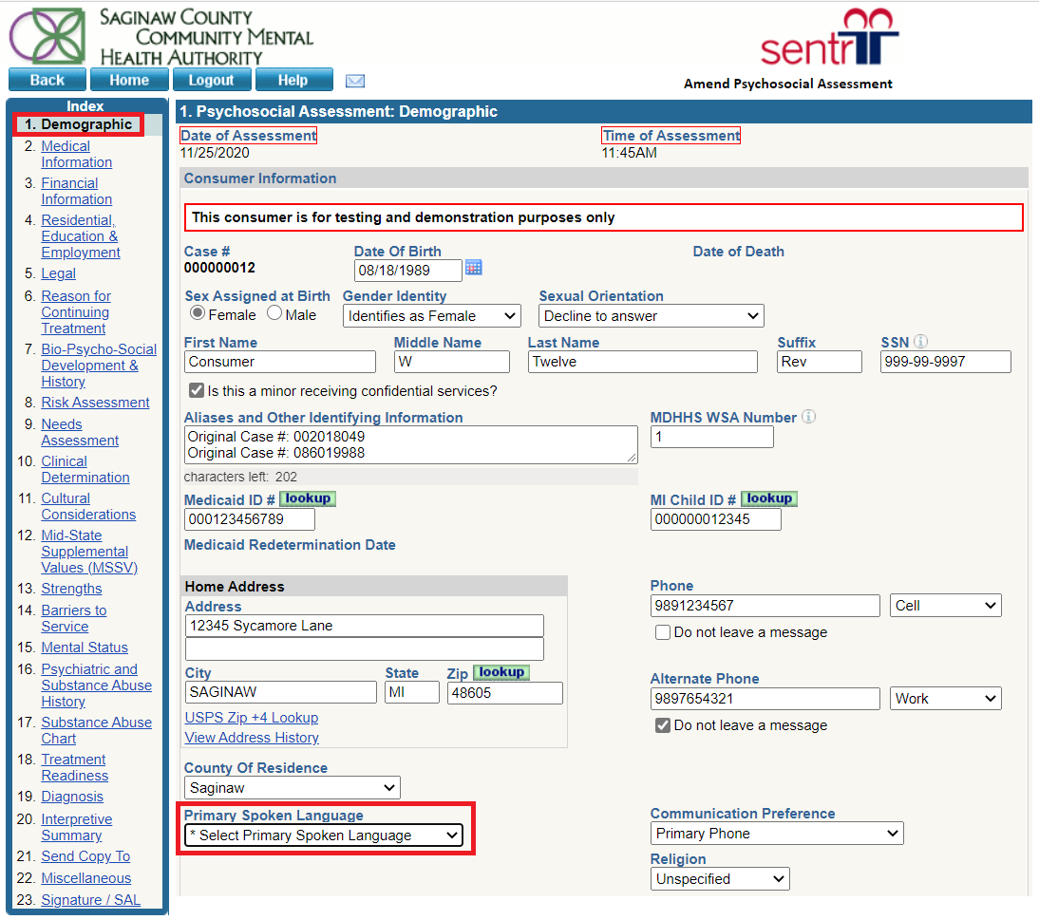

Obligations to Assist Person served and the Role of the Guardian
- If a guardian can communicate information to the person served who is considered to have LEP, we do not have the same obligation as we do when a person served is their own guardian and is considered to have LEP.
- This does not mean that we do not need to take steps to communicate in a manner that the person served understands.
- Example: A person served speaks Spanish and doesn’t understand English. The guardian reads and speaks English but doesn’t communicate in Spanish. We still need to provide interpretation for the person served, as they would not understand your communication with the guardian, and we need to be able to communicate with the person served to whom we are providing a service.

