Policy and Procedure Manual
Saginaw County Community Mental Health Authority
Subject: Recipient Rights – Abuse and Neglect | Chapter: 02 -  Customer Services and Recipient Rights | Subject No: 02.02.11
Effective Date:  March 7, 2000 | Date of Review/Revision:  2/19/03, 7/25/07, 1/25/08, 6/29/09, 5/24/10, 7/20/12, 11/1/12, 6/13/14, 11/27/16, 6/6/18, 1/8/19, 2/11/20, 2/9/21, 5/10/22, 3/14/23 | Approved By:  Sandra M. Lindsey, CEO  Responsible Director:  Director of  Customer Services, Recipient Rights, & Security  Authored By:  Director of  Customer Services, Recipient Rights, & Security  Additional Reviewers:
Effective Date:  March 7, 2000 | Supersedes:  06.02.17.00
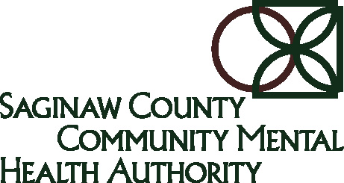

Purpose:
The purpose of this policy is to protect consumers of Saginaw County Community Mental Health Authority (SCCMHA) services from abuse and neglect and to ensure that suspected abuse and neglect is reported to the proper authorities.

Policy:
It is the policy of Saginaw County Community Mental Health Authority (SCCMHA) that suspected abuse or neglect of recipients receiving public mental health services will be dealt with immediately.

Application:
This policy applies to all SCCMHA direct operated programs as well as all SCCMHA Service Provider Network programs.

Standards:
C1) Abuse is defined in the Definitions Section of this policy. The detailed categories of abuse by type and severity are defined in the Definitions Section of this policy.

C2) Neglect is defined in the Definitions Section of this policy. The detailed categories of neglect by type and severity are defined in the Definitions Section of this policy.

C3) All SCCMHA and SCCMHA Service Provider Network program staff are required to report any suspected abuse, neglect, exploitation, or humiliation to the appropriate authorities immediately. The reporting requirements are delineated in Procedures #3, 5, 6, 7, & 8 below, as well as the attached Summary of Abuse and Neglect Reporting Requirements poster (DCH-0727).

C4) The SCCMHA ORR will investigate any and all allegations of suspected abuse, neglect, exploitation, or humiliation and will initiate the investigation (in areas where ORR has jurisdiction) immediately (within 24 hours of the notification). The SCCMHA ORR will have access to all information necessary to complete a thorough investigation.

C5) When suspected allegations of abuse, neglect, exploitation, or humiliation are substantiated, remedial action and firm and appropriate disciplinary action will be taken. When suspected allegations are reported, the staff who is suspected of committing the abuse, neglect, exploitation, or humiliation toward a consumer will be suspended until the SCCMHA ORR has enough information to ensure the safety of the consumer(s) involved. This determination is made based on a case by case basis by the SCCMHA ORR.

C6) As stated in Procedure #3 below, it is the responsibility of the staff person who has
the knowledge of the suspected allegation of abuse, neglect, exploitation, or humiliation to report this information to the appropriate authorities immediately.

C7) All SCCMHA and SCCMHA Service Provider Network programs staff are required to report suspected criminal abuse including Vulnerable Adult Abuse and Child Abuse to local law enforcement immediately as described in Procedures #5, 6, 7, & 8 below, as well as the attached Summary of Abuse and Neglect Reporting Requirements poster (DCH-0727 – Revised 4/2018).

C8) The written report to law enforcement referenced in Procedure #6 below will be made using the Report on Alleged Recipient Abuse-Neglect-Exploitation located on the G Drive of the SCCMHA Information System Network under Agency Forms/Clinical Forms. This form is not required by the SCCMHA Provider Network but is available to them upon request. This report will be made by the SCCMHA or SCCMHA Service Provider Network staff who is aware of the suspected allegation of abuse or neglect.

C9) Definitions of Degrade and threaten are listed in the Definitions section.

C10) Any mental health professional employed by SCCMHA or any of its Provider Network (ultimately under contract with the Michigan Department of Health and Human Services (MDHHS), who has reasonable cause to suspect abuse, neglect, exploitation, or humiliation, is required to report this information to the appropriate authorities immediately.

C11) As stated in the Application Section of this policy, this policy applies to all SCCMHA direct operated programs as well as all SCCMHA Service Provider Network programs.

C12) The worth, dignity, and uniqueness of all consumers, as well as their rights and opportunities, shall be respected and promoted.

C13) Any instance of physical, psychological, sexual or other types of abuse or neglect of consumers will not be acceptable and staff members responsible for these types of actions will be considered for disciplinary action up to and including discharge.

C14) A consumer of SCCMHA shall not be subjected to abuse or neglect.

C15) A consumer who is abused or neglected has the right to pursue injunction and other appropriate civil relief.

C16) Consumers who feel they have been abused or neglected should follow reporting procedures and complete a rights complaint form with the assistance from the Office of Recipient Rights if requested.

C18) Any individual who makes a report under Section 330.1722 of the Michigan Mental Health Code shall not be dismissed or otherwise penalized by an employer or contractor for making the report.

C19) Suspected exploitation or humiliation as defined in this policy will be considered a violation of abuse and will be investigated with the same procedures as abuse or neglect. A substantiated allegation of exploitation or humiliation will require disciplinary action.

Definitions:
Abuse- Defined as follows: "Abuse" means non-accidental physical or emotional harm to a consumer, or sexual contact with or without sexual penetration of a consumer as those terms are defined in section 520a of the Michigan penal code, 1931 PA 328, MCL 750.520a, that is committed by an employee or volunteer of the department, a community mental health services program, or a licensed hospital or by an employee or volunteer of a service provider under contract with the department, community mental health services program, or licensed hospital.
(a) Class I – A non-accidental act or provocation of another act by an employee, volunteer, or agent of a provider that caused or contributed to death, serious physical harm or sexual abuse of a consumer;

(b) Class II – Means any of the following:
i) A non-accidental act or provocation of another to act by an employee, volunteer, or agent of a provider that caused or contributed to non-serious physical harm to a consumer;
ii) The use of unreasonable force on a consumer by an employee, volunteer, or agent of a provider with or without apparent harm;
iii) An action or provocation of another to act by an employee, volunteer, or agent of a provider that causes or contributes to emotional harm to a consumer.
iv) An action taken on behalf of a consumer by assuming incompetence, although a guardian has not been appointed or sought, that results in substantial economic, material, or emotional harm to the consumer.
- v) Exploitation of a consumer by an employee, contract employee or volunteer.

(c) Class III – The use of language or other means of communication by an employee, volunteer, or agent of a provider to degrade, threaten, or sexually harass a consumer.

(d) Unreasonable force means physical management or force that is applied by an employee, volunteer, or agent of a provider to a recipient in one or more of the following circumstances:
(i) There is no imminent risk of serious or non-serious physical harm to the recipient, staff or others.
(ii) The physical management used is not in compliance with techniques approved by the provider and the responsible mental health agency.
(iii) The physical management used is not in compliance with the emergency interventions authorized in the recipient's individual plan of service.
(iv) The physical management or force is used when other less restrictive measures were possible but not attempted immediately before the use of physical management or force.

Neglect- Defined as follows: "Neglect" means an act or failure to act committed by an employee or volunteer of the department, a community mental health services program, or a licensed hospital; a service provider under contract with the department, community mental health services program, or licensed hospital; or an employee or volunteer of a service provider under contract with the department, community mental health services program, or licensed hospital, that denies a consumer the standard of care or treatment to which he or she is entitled under this act. (330.1100b)
(i) Class I – Means any of the following:
(i) Acts of commission or omission by an employee, volunteer, or agent of a provider that results from non-compliance with a standard of care or treatment required by law, rules, policies, guidelines, written directives, procedures, or individual plans of service and causes or contributes to the death, or sexual abuse of, or serious physical harm to a consumer.
(ii) The failure to report abuse or neglect of a consumer when the abuse or neglect results in death or serious physical harm to the consumer.
(j) Class II – Means any of the following:
(i) Acts of commission or omission by an employee, volunteer, or agent of a provider that results from non-compliance with a standard of care or treatment required by law, rules, policies, guidelines, written directives, procedures, or individual plans of service and that cause or contribute to non-serious physical harm or emotional harm to a consumer;
(ii) The failure to report abuse or neglect of a consumer when the abuse or neglect results in non-serious harm to the consumer.
(k) Class III-Means any of the following:
(i) Acts of commission or omission by an employee, volunteer, or agent of a
provider that result from noncompliance with a standard of care or treatment
required by law and/or rules, policies, guidelines, written directives, procedures, or individual plan of service that either placed or could have placed a recipient at risk of physical harm or sexual abuse;
(ii) The failure to report apparent or suspected abuse Class III or neglect Class III
of a recipient.

Criminal Abuse:
(1) An assault that is a violation or an attempt or conspiracy to commit a violation of sections 81 to 90 of the Michigan penal code, Act No. 328 of the Public Acts of 1931, being sections 750.81 to 750.90 of the Michigan Compiled Laws. Criminal abuse does not include an assault or an assault and battery that is a violation of section 81 of Act No. 328 of the Public Acts of 1939, being section 750.81 of the Michigan Compiled Laws, and that is committed by a consumer against another consumer.
(2) A criminal homicide that is a violation or an attempt or conspiracy to commit a violation of section 316, 317, or 321 of Act No. 328 of the Public Acts of 1931, being sections 750.316, 750.317, and 750.321 of the Michigan Compiled Laws.
(3) Criminal sexual conduct is a violation or an attempt or conspiracy to commit a violation of sections 520b to 520e or 520g of Act No. 328 of the Public Acts of 1931, sections 750.520b to 750.520e and 750.520g of the Michigan Compiled Laws involving an employee, volunteer, or agent of a provider and a consumer.
(4) Vulnerable adult abuse that is a violation or an attempt or conspiracy to commit a violation of section 145n of the Michigan penal code, Act No. 328 of the Public Acts of 1931, being section 750.145n of the Michigan Compiled Laws.
(5) Child abuse that is a violation or an attempt or conspiracy to commit a violation of section 136b of Act No. 328 of the Public Acts of 1931, being section 750.136b of the Michigan Compiled Laws.

Degrade: means any of the following:
- To cause a humiliating loss of status or reputation;
- To cause the person to feel that they or other people are worthless and do not have the respect or good opinion of others;
- To deprive of self esteem or self worth; to shame or disgrace;
- Language of epitaphs that insult the person’s heritage, mental status, race sexual orientation, gender, intelligence; etc.

Examples of behavior that is degrading and must be reported as abuse include but is not limited to:
- swearing at consumers
- Using foul language at consumers
- Using racial or ethnic slurs at consumers
- Causing or prompting others to commit the actions listed above.

Emotional Harm: Impaired psychological functioning, growth, or development of a significant nature as evidenced by observable physical symptomatology or as determined by a mental health professional.

Exploitation: An action by an employee, volunteer, or agent of a provider that involves the misappropriation or misuse of a consumer’s property or funds for the benefit of an individual or individuals other than the consumer.

Humiliation: To reduce to a lower position in one’s own eyes or others’ eyes; extremely destructive to one’s self-respect or dignity.

Sexual Abuse: means any of the following:
- as described in section (3) above under Criminal abuse
- Any sexual contact or sexual penetration involving an employee, volunteer, or agent of a provider and a consumer
- Any sexual contact or sexual penetration involving an employee, volunteer, or agent of a provider and consumer for whom the employee or agent provides direct services

Sexual Contact: means the intentional touching of the consumer’s or employee’s intimate parts or the touching of the clothing covering the immediate area of the consumer’s or employee’s intimate parts, if that intentional touching can reasonably be construed as being for the purpose of sexual arousal or gratification, done for a sexual purpose, or in a sexual manner for any of the following:
- Revenge
- To inflict humiliation
- Out of anger

Sexual Harassment: means sexual advances to a consumer, requests for sexual favors from a consumer, or conduct or communication of a sexual nature toward a consumer.
Sexual Penetration: means sexual intercourse, cunnilingus, fellatio, anal intercourse, or any other intrusion, however slight, or any part of a person’s body or of any object into the genital or anal openings of another person’s body, but emission of semen is not required.

Threaten: means either of the following:
- To utter intentions of injury or punishment against.
- To express a deliberate intention to deny the well-being, safety or happiness of somebody unless the person does what is being demanded.
Unreasonable Force: means physical management or force that is applied by an employee, volunteer, or agent of a provider to a consumer in one or more of the following circumstances:
- There is no imminent risk of serious or non-serious physical harm to the consumer, staff or others.
- The physical management used is not in compliance with techniques approved by the provider and the responsible mental health agency.
- The physical management used is not in compliance with the emergency interventions authorized in the consumer’s individual plan of service.
- The physical management or force is used when other less restrictive measures were possible but not attempted immediately before the use of physical management or force.

References:
Administrative Rules 330.7001
Administrative Rules 330.7035
Michigan Mental Health Code 330.1722;
Michigan Mental Health Code 330.1723;
Michigan Mental Health Code 330.1778

Exhibits:
Exhibit A - Staff Action Regarding Alleged Abuse/Neglect/Exploitation form
Exhibit B - Summary of Abuse and Neglect Reporting Requirements, Rev. 4/2018

Procedure:
ACTION | RESPONSIBILITY
- SCCMHA and Provider Network staff along with the Recipient Rights Office will work to protect the consumers of mental health services from abuse and neglect.  - Whenever an injury is suffered regarding suspected abuse or neglect, staff are responsible for ensuring that the consumer(s) receives immediate proper treatment, comfort and protection as necessary and that action taken by staff sufficiently addresses the urgency of the injury.  - In all cases of abuse, neglect and/or mistreatment, it is the assigned duty and responsibility of the staff who has knowledge of or reasonable cause to suspect consumer abuse, neglect or mistreatment to immediately report it to their immediate supervisor, the Recipient Rights Office, administration, law enforcement, Protective Services, and the Department of Licensing and Regulatory Affairs (LARA), and other agencies as required by law.  - Appropriate disciplinary action will be taken against anyone proven to have engaged in abuse or neglect. Proof will come through a Recipient Rights Office investigation or a criminal investigation completed by a law enforcement agency or recognized court of law.  - Any mental health professional employed by SCCMHA or any of its Provider Network (ultimately under contract with the Michigan Department of Health and Human Services), who has reasonable cause to suspect the criminal abuse including Vulnerable Adult Abuse and Child Abuse will immediately make a call or cause a call to be made, by telephone or otherwise to the law enforcement agency for the county or city in which the criminal abuse is suspected to have occurred or to the state police.  - Within 72 hours after making the oral report, the reporting individual shall file a written report (using the attached form – Report on Alleged Recipient Abuse-Neglect-Exploitation) with the law enforcement agency to which the oral report was made and with the chief administrator of the facility or agency responsible for the consumer. This report will also be made to the Recipient Rights Office of SCCMHA.  - The written report required in #6 of these procedures will contain the name of the consumer and a description of the criminal abuse and the manner in which it occurred. The report will become a part of the sentri Incident Report Module.  - The identity of an individual who makes a report is confidential and is not subject to disclosure without the consent of that individual or subpoena of a court of record. An individual acting in good faith who makes a report of criminal abuse against a consumer is immune from civil or criminal liability that might otherwise be incurred.  - Reporting the suspected abuse or neglect to the legal authorities will not preclude nor hinder the Recipient Rights Office of the department, a licensed facility, SCCMHA or any of its Provider Network from investigating the report of suspected abuse or neglect and from taking appropriate disciplinary action against its employees based upon that investigation. | - SCCMHA, Provider Network staff, and the SCCMHA Recipient Rights Office  - Staff responsible for supervision of consumers  - Staff or Supervisor with the knowledge of abuse or neglect  - SCCMHA Chief Executive Officer and Administrative staff of the SCCMHA Service Provider Network  - Mental health professionals employed or contracted with SCCMHA or any of its Provider Network.  - The mental health professional making the report of suspected abuse or neglect  - The mental health professional making the report of suspected abuse or neglect will send the report to the SCCMHA ORR  - SCCMHA and its Provider Network will protect the individual making the good faith report  - Recipient Rights Office

Exhibit A
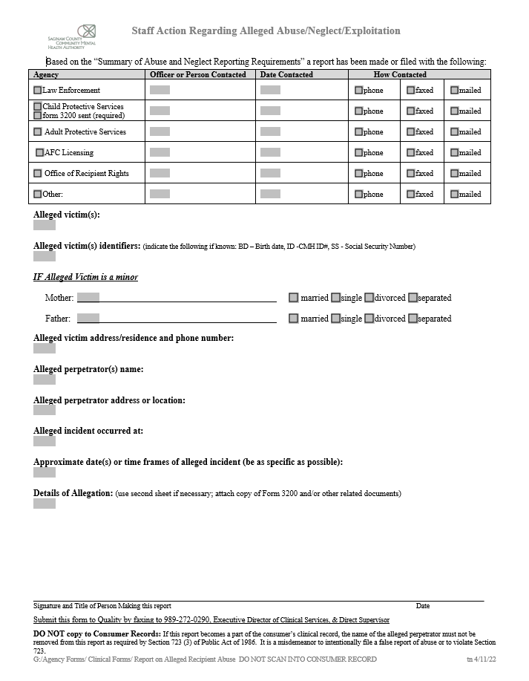

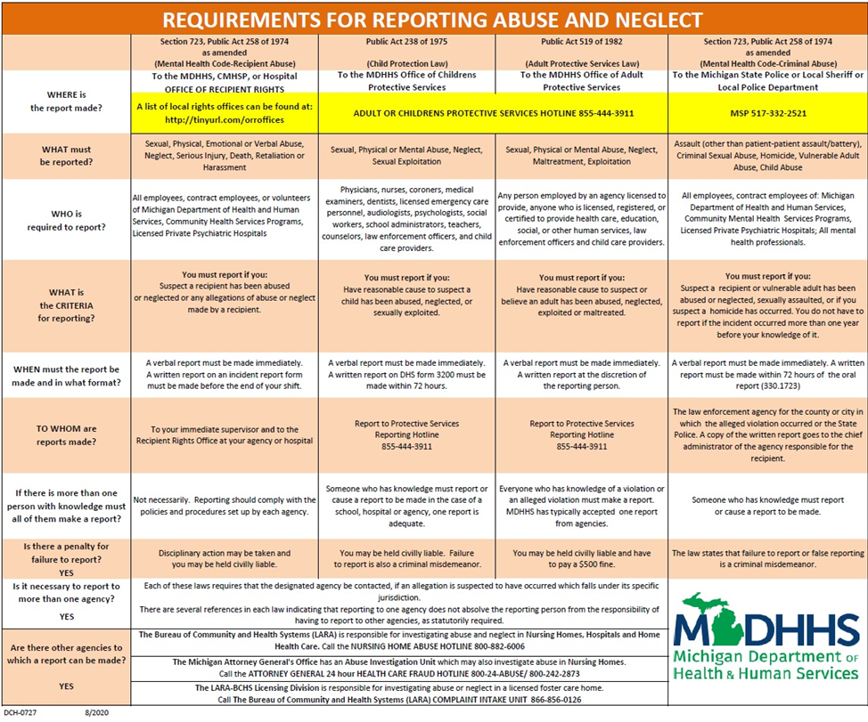
Exhibit B
Exhibit B
Exhibit B

