
Data Comparison of the

Fiscal Years (FY) 2009-2013

ORR Annual Reports
Recipient Rights Annual Report Six Year Comparison
Fiscal Years (FY) 2016 – 2021

Prepared for the Recipient Rights Advisory Committee, November 2022

Saginaw County Community
Mental Health Authority
Office of Recipient Rights
(989) 797-3452
www.sccmha.org

Saginaw County Community
Mental Health Authority
Office of Recipient Rights
(989) 797-3452
www.sccmha.org

Saginaw County Community
Mental Health Authority

**************************************************
Office of Recipient Rights
(989) 797-3452
www.sccmha.org

**************************************************

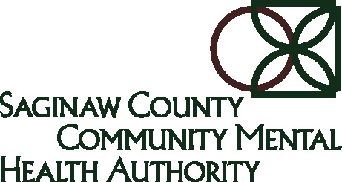 | SCCMHA  Office of Recipient Rights  Data Comparison of the  FY 2016 - 2021  Annual Reports | 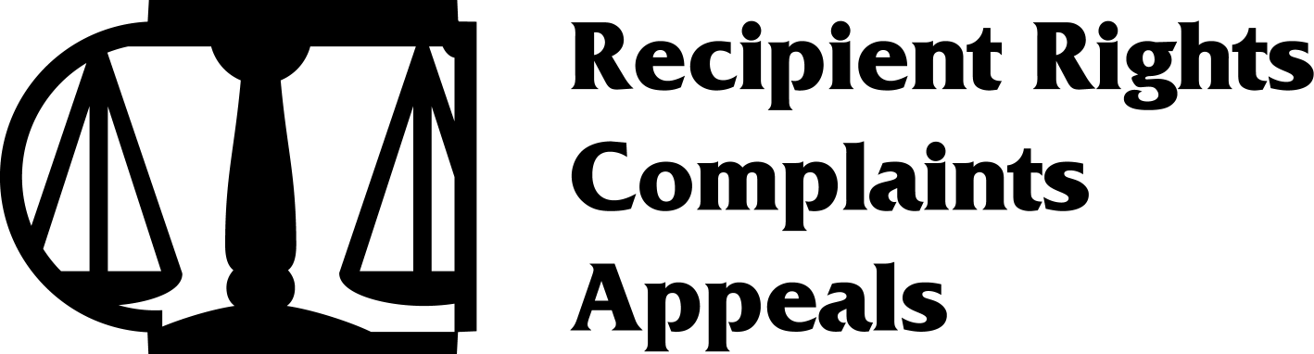
INTRODUCTION
The Michigan Mental Health Code requires Community Mental Health (CMH) agencies to have an Office of Recipient Rights (ORR) to provide and coordinate the protection of Recipient Rights for all directly operated or contracted services. The Saginaw County Community Mental Health Authority (SCCMHA) Office of Recipient Rights has been given the most prominent area of the main 500 Hancock facility to allow those served easy access to make a complaint. The purpose of the SCCMHA ORR is for protecting the Rights of the people we serve. This report is used to review and analyze data from the required Annual Reports to determine if there are ways to better protect SCCMHA consumers. We are reviewing data from the past 6 Fiscal Years to determine any trends that may be developing.

This report will be submitted to the ORR Committee, the SCCMHA and the Quality Governance Committee by December 2022.

SITE VISITS
The Michigan Mental Health Code requires every site serviced by SCCMHA to be visited by the ORR annually. On the chart below, the number on the left represents the number of sites serviced by SCCMHA and the number on the right represents the number of sites visited by the SCCMHA ORR. As the chart indicates, over the past six years the SCCMHA ORR has completed 100% of the required Site Visits achieving the established goal.

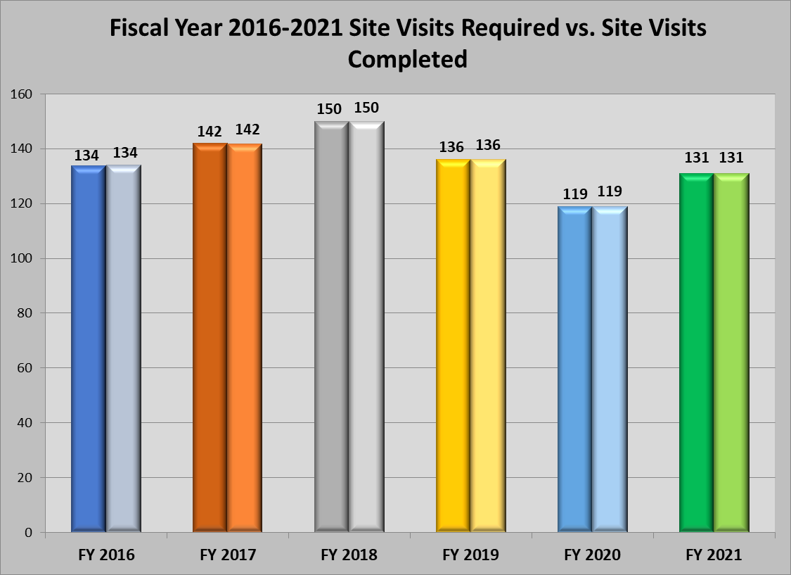

Recipient Rights Data
The SCCMHA ORR Investigations and Interventions data is maintained in the sentri  electronic record system. The data included in this report was pulled from the following table:
Headings | FY 2016 | FY 2017 | FY 2018 | FY 2019 | FY 2020 | FY 2021
Out of Jurisdiction | 19 | 24 | 12 | 17 | 9 | 17
No Right Involved | 15 | 27 | 8 | 6 | 4 | 7
Interventions | 0 | 6 | 1 | 4 | 2 | 1
Investigated Complaints | 160 | 152 | 116 | 181 | 157 | 259
Total Number of Allegations Involved | 194 | 209 | 137 | 208 | 172 | 283
Substantiated Allegations | 117 | 97 | 74 | 100 | 85 | 131
Complaints Received (Includes NRI & OJ) | 194 | 203 | 136 | 204 | 170 | 283
Number of People Served | 6,210 | 6,989 | 7,523 | 7,725 | 7,292 | 7,644
Unduplicated Number of Complainants | 83 | 103 | 65 | 94 | 75 | 75
Number of Required Site Visits | 134 | 142 | 150 | 136 | 119 | 131
Number of Site Visits Completed | 134 | 142 | 150 | 136 | 119 | 131
Substantiated Abuse | 20 | 28 | 20 | 25 | 10 | 22
Substantiated Neglect | 58 | 44 | 24 | 31 | 30 | 53
All Sub Allegations Other Than Abuse & Neglect | 39 | 25 | 30 | 44 | 45 | 56

COMPLAINTS RECEIVED AND ALLEGATIONS INVOLVED
There is a difference between Complaints and Allegations. When a Complaint is received by the ORR, it is the responsibility of the SCCMHA ORR to document complaint information in the record. If there is an allegation of abuse or neglect, the SCCMHA ORR must immediately act to initiate the investigation and determine how many allegations of potential code protected Rights violations are involved. Because there may be multiple Allegations for each Complaint, there is always a potential to have more Allegations than Complaints.

The chart below shows the number of Complaints and Allegations have increased significantly for FY 2016 through FY 2021. Over a six year period there is regular fluctuation in the number of complaints received and investigated. However, in FY 2021 there was a very large increase in the volume of complaints. This was in the middle of the COVID 19 Pandemic and there could be several contributing factors for this rise. The Pandemic started having an effect on the public mental health system in March, 2020. There were a large number of staff changes in Adult Foster Care (AFC) Homes. Some of these changes had the effect of residents of AFC Homes losing long term relationships with staff and there was also a lack of quality staff and a large turnover of staff. This could have had an affect on people being unhappy overall, which could lead to a larger number of complaints.

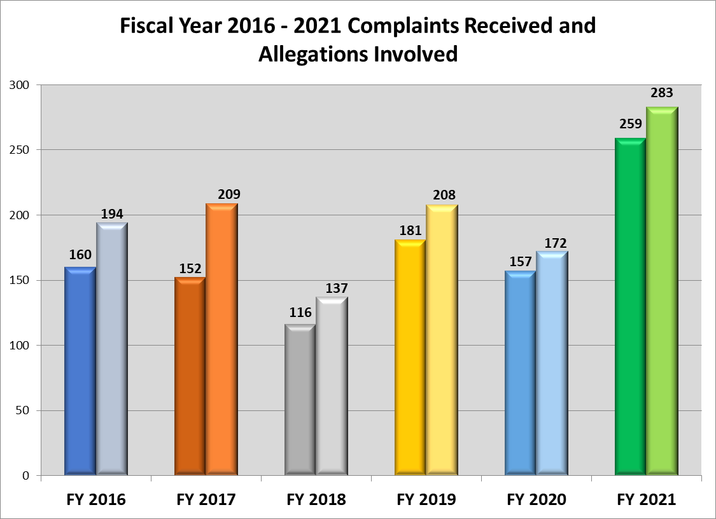

ALLEGATIONS INVESTIGATED, INTERVENTIONS, NO RIGHT INVOLVED, AND OUT OF JURISDICTION
An important aspect of the ORR process is understanding how Complaints are processed. When a Complaint is reported to the SCCMHA ORR, it is categorized as an Investigation, an Intervention, a No Right Involved, or an Out of Jurisdiction. The definition of each of these categories is defined below:
- Investigation: A right as defined in the Michigan Mental Health Code is alleged to have been violated and the facts of the allegation are not clear without looking into the allegation on a deeper level.
- Intervention: An allegation of a right has been reported to the SCCMHA ORR in which the facts, remedy, and resolution are clear. It is important to note that a case of abuse, neglect, or retaliation may not be opened as an Intervention.
- No Right Involved: An alleged violation of a person’s rights that is not defined by the Michigan Mental Health Code.
- Outside of Jurisdiction: An alleged violation of a person’s rights where the SCCMHA ORR would not have the authority to investigate.

The chart below shows the number of Allegations Investigated in FY 2021 was the largest number of allegations in several years. The possible reason for this increase was explained above.

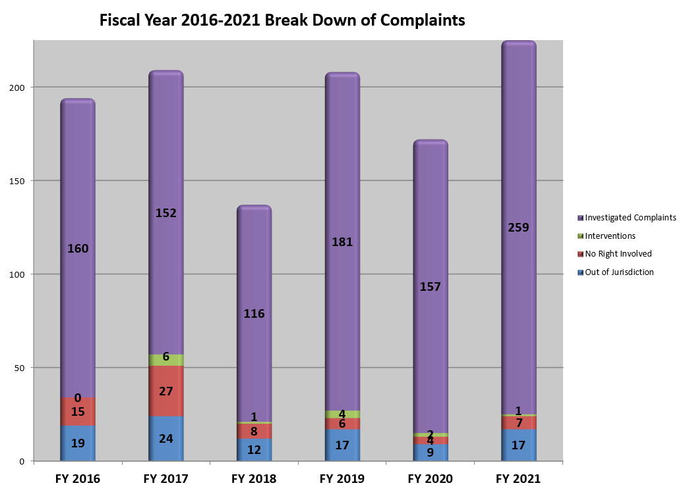

NUMBER OF CONSUMERS SERVED
The chart below shows the number of People Served over the past 6 years. The number of People Served has consistently increased over the last 6 years. This is in large part because the SCCMHA Chief Executive Officer, Sandra Lindsey has had a goal to serve more people over the past several years. There has been a slight decrease over the past couple of years due to the COVID 19 Pandemic. By serving more people SCCMHA provides a better life to the entire community. Over the past 6 years the number of people served went from 6,210 in FY 2016 to a high of 7,725 in FY 2019 which is an increase of 24%.

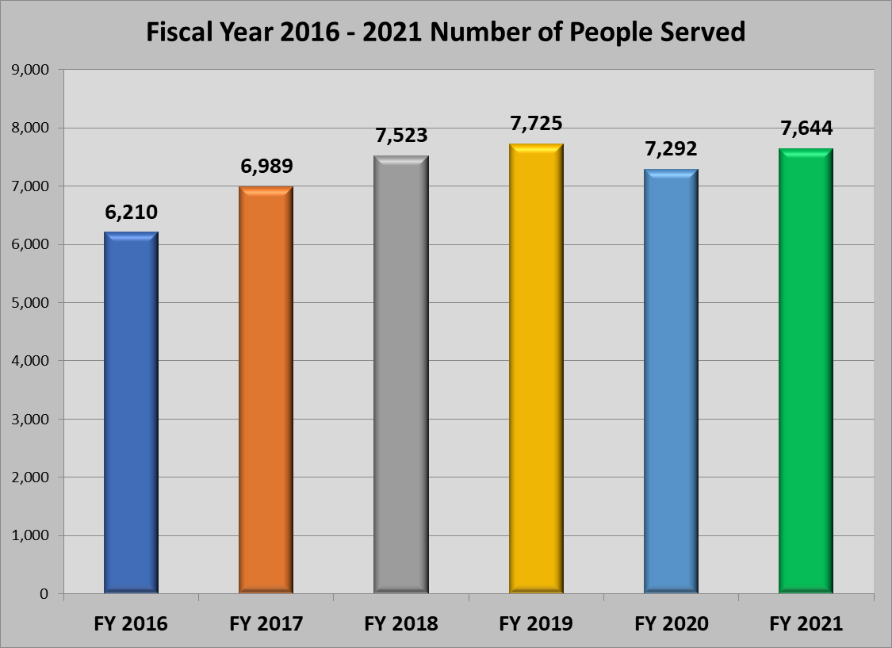

ABUSE & NEGLECT
The categories of Abuse and Neglect are the most important categories of investigations because it directly impacts recipient health and safety! It is important to know the types of allegations that are involved in the Abuse and Neglect categories.

The following are examples of Neglect: leaving a recipient’s medications unattended, medication errors, failure to seek medical attention for a fall, not following a written standard of care required by law or written standard, and failure to report apparent or suspected abuse or neglect.

The following are examples of Abuse: sexual harassment, hitting, slapping, kicking a recipient, use of weapons, foul language, racial or ethnic slurs, misuse or misappropriation of recipient funds, and unreasonable force.

Abuse and neglect are separated into three different types; both can be Class I, Class II, and Class III. The most serious of both abuse and neglect is Class I and the least serious is Class III.

The chart below shows the number of Substantiated Abuse Complaints was the highest in FY 2017. There were a couple of years where substantiated abuse decreased. It is always a relief to see a reduction of substantiated abuse, but our goal is to get the number to zero.
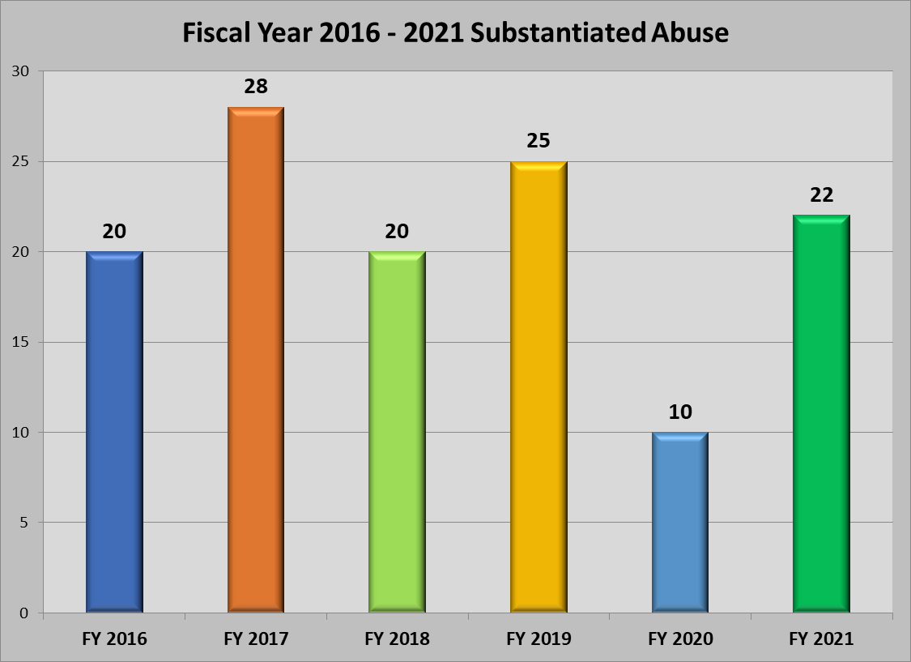

In FY 2016 the number of substantiated neglect nearly doubled. This is an obvious problem when our job is to protect consumers. After FY 2016 the SCCMHA ORR made a concerted effort to work with AFC Homes closely and offer consultations for anyone who had questions. The involvement in the Home Manager Training annually also allows for the SCCMHA ORR to answer any questions where there might be an uncertainty and it allows a more personal connection between the SCCMHA ORR and Home Managers. Over the next four years there was an obvious decrease in substantiated neglect. Unfortunately there was an increase in this number in FY 2021. There are some educated guesses on the increase and part of this was related to holding people in the system more accountable. The SCCMHA ORR remains dedicated to reducing the number of substantiated neglect cases.

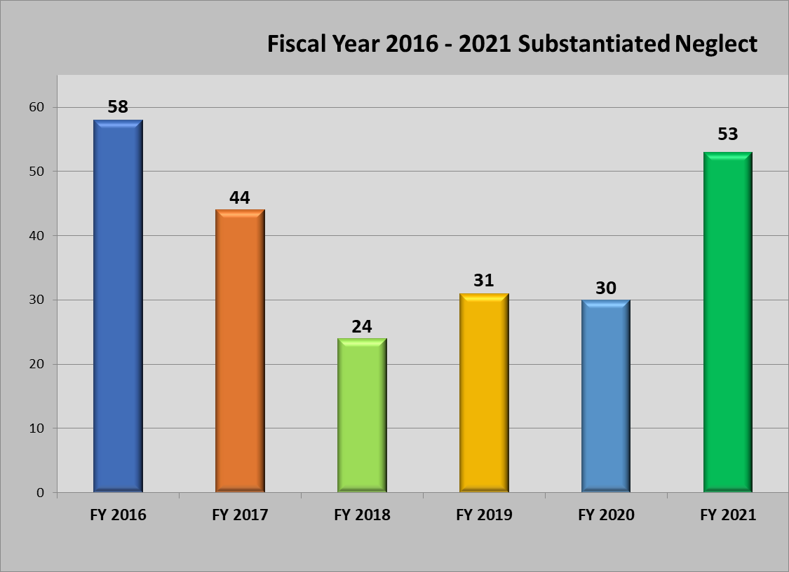

The Office of Recipient Rights is dedicated to protect the rights of the people we serve!



