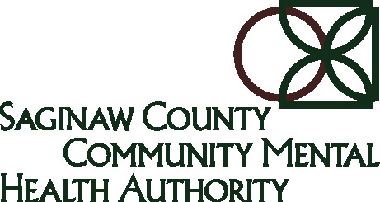 | Office of Recipient Rights  Action Verification Form | 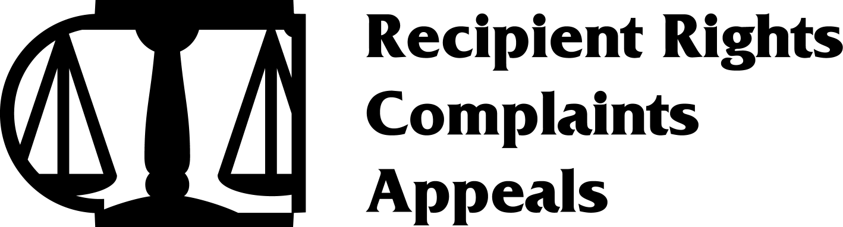

Recipient(s) (If you type recipient name on this form, please do not send by regular e-mail)

Provider Agency (Agencies) | Provider/Respondent | Report #

Instructions: Please review the attached Office of Recipient Rights Intervention/Investigation Report. Document below the steps that have been taken or will be taken to comply with the recommendations in the report (include what action was/will be taken, when it was/will be taken and by whom). Attach additional pages if necessary. Sign and date your response and send the
completed form to:

Judy Sausedo
jsausedo@sccmha.org
Phone: (989) 797-3462
Fax: (989) 797-3595

OR

Juwan Chapman
jchapman@sccmha.org
Phone: (989) 797-3583
Fax: (989) 797-3595

Please note: If disciplinary action has been recommended, please indicate which of the following actions was/will be taken with staff: written reprimand, suspension, demotion, staff transfer or employment termination.

This completed form is due back to the Office of Recipient Rights on or before:
Action Taken:
PLEASE PROVIDE COPIES OF ANY ACTION TAKEN

Signature and Title: _______________________________________________ Date: ___________

